Normal Regulation of Blood Glucose

The Important Roles of Insulin and Glucagon: Diabetes and Hypoglycemia
Written by James Norman MD, FACS, FACE
https://www.endocrineweb.com/conditions/diabetes/normal-regulation-blood-glucose

The human body wants blood glucose (blood sugar) maintained in a very narrow range. Insulin and glucagon are the hormones which make this happen. Both insulin and glucagon are secreted from the pancreas, and thus are referred to as pancreatic endocrine hormones. The picture on the left shows the intimate relationship both insulin and glucagon have to each other. Note that the pancreas serves as the central player in this scheme. It is the production of insulin and glucagon by the pancreas which ultimately determines if a patient has diabetes, hypoglycemia, or some other sugar problem.

In this Article
- Insulin Basics: How Insulin Helps Control Blood Glucose Levels
- The Role of Glucagon in Blood Glucose Control
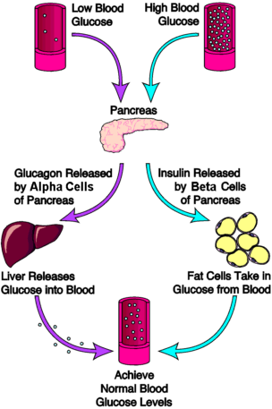

Learn More about Blood Glucose Control
- How to Have Tight Blood Glucose Control
- Insulin's Role in Blood Glucose Control

Insulin Basics: How Insulin Helps Control Blood Glucose Levels
Insulin and glucagon are hormones secreted by islet cells within the pancreas. They are both secreted in response to blood sugar levels, but in opposite fashion!
Endocrinologists Information - Access Treatment Information
www.hypogonadism-hcpinfo.com
View Physician Information About Hypogonadism Due To Certain Medical Conditions.
Insulin is normally secreted by the beta cells (a type of islet cell) of the pancreas. The stimulus for insulin secretion is a HIGH blood glucose...it's as simple as that! Although there is always a low level of insulin secreted by the pancreas, the amount secreted into the blood increases as the blood glucose rises. Similarly, as blood glucose falls, the amount of insulin secreted by the pancreatic islets goes down.
As can be seen in the picture, insulin has an effect on a number of cells, including muscle, red blood cells, and fat cells. In response to insulin, these cells absorb glucose out of the blood, having the net effect of lowering the high blood glucose levels into the normal range.
Glucagon is secreted by the alpha cells of the pancreatic islets in much the same manner as insulin...except in the opposite direction. If blood glucose is high, then no glucagon is secreted.
When blood glucose goes LOW, however, (such as between meals, and during exercise) more and more glucagon is secreted. Like insulin, glucagon has an effect on many cells of the body, but most notably the liver.

The Role of Glucagon in Blood Glucose Control
The effect of glucagon is to make the liver release the glucose it has stored in its cells into the bloodstream, with the net effect of increasing blood glucose. Glucagon also induces the liver (and some other cells such as muscle) to make glucose out of building blocks obtained from other nutrients found in the body (eg, protein).
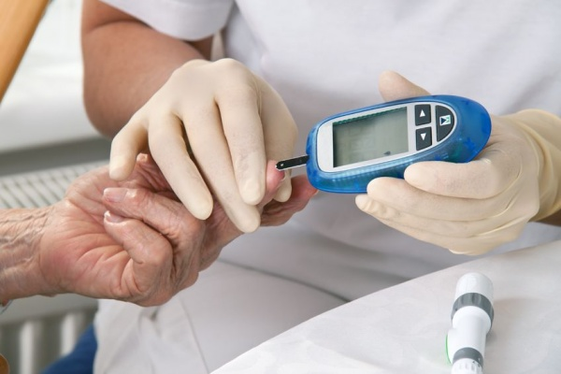Our bodies desire blood glucose to be maintained between 70 mg/dl and 110 mg/dl (mg/dl means milligrams of glucose in 100 milliliters of blood). Below 70 is termed "hypoglycemia." Above 110 can be normal if you have eaten within 2 to 3 hours. That is why your doctor wants to measure your blood glucose while you are fasting...it should be between 70 and 110. Even after you have eaten, however, your glucose should be below 180. Above 180 is termed "hyperglycemia" (which translates to mean "too much glucose in the blood"). If your 2 two blood sugar measurements above 200 after drinking a sugar-water drink (glucose tolerance test), then you are diagnosed with diabetes.

